14 December 2018

Submission of comments on ICH Guideline Q12 on technical and regulatory considerations for pharmaceutical product lifecycle management Step 2b (EMA/CHMP/ICH/804273/2017)

Comments from:
Name of organisation or individual
AESGP + APIC + EFPIA/EBE/Vaccines Europe + Medicines for Europe

Please note that these comments and the identity of the sender will be published unless a specific justified objection is received.
When completed, this form should be sent to the European Medicines Agency electronically, in Word format (not PDF).

- General comments
Stakeholder number  (To be completed by the Agency) | General comment (if any) | Outcome (if applicable)  (To be completed by the Agency)
Introduction – Compatibility of Q12 with legal frameworks (Ch 1.1, line 81)
The EU Trade Associations acknowledge that legal assessments have indicated that current regulatory framework in some regions/countries may not be fully compatible with some of the principles foreseen in ICH Q12, such as the use of explicit Established Conditions and the Product Lifecycle Management document. However, it is unclear how selective adoption of parts of ICH Q12 will consequently lead to harmonization and reduction of regulatory burden.

It is critical that all ICH partners work together to develop a Step 4 document that omits the text added in the introduction of Step 2B draft Q12 document:

"In certain ICH regions, the current ICH Q12 guideline is not fully compatible with the established legal framework with regard to the use of explicit Established Conditions ('EC') referred to in Chapter 3 and with the Product Lifecycle Management ('PLCM') referred to in Chapter 5 as outlined in this guideline. These concepts will, however, be considered when the legal frameworks will be reviewed and, in the interim, to the extent possible under the existing regulation in these ICH regions.”

The draft guideline allows for regional regulatory interpretations in several areas (the term ‘region/regional’ is mentioned multiple times). There is a real risk of divergence across countries/regions, for example in terms of approved ECs and reporting categories (which are by default regional), or in approval of a PACMP, and in even more divergence in regulatory documentation and approval timelines. In addition, the regulatory burden during implementation can be even greater due to different understanding from different authorities of old and new concepts. The original goal to harmonize and facilitate life cycle management across region will be compromised if the guideline allows a disharmonized approach on technical and regulatory considerations for lifecycle management.

In addition, lines 552-555 (Chapter 8) include text allowing regional implementation of this chapter: the concept of harmonisation will be jeopardized if specific changes may require prior approval as defined in regional guidance.

Proposed change (if any):
The Joint EU Trade Associations recommend that introductory text regarding the compatibility of Q12 with legal frameworks is removed from the guideline because the legal aspects of implementation of ICH guidelines are best addressed through the ICH Assembly and Management Committee. Such legal aspects are beyond the competence of an Expert Working Group and should not be addressed in a Guideline. Rather we believe that they are best addressed through the development of general principles and obligations concerning the timely implementation of ICH guidelines by existing and future members of ICH, that would be agreed by the ICH Assembly, and that would provide predictability for industry and regulators.

In addition we recommend that the text in chapter 8 (lines 552 -555) is also deleted, for the same reason as the removal of the Introductory text discussed above.
Established Conditions (Chapter 3)
For the EC concept to be a useful regulatory tool across the ICH regions it is desirable that regulatory agencies approve the same definition of ECs in a dossier and, the same reporting categories.
We encourage dialogue between regulatory agencies to facilitate convergence and consistent outcomes in the review/approval of proposed ECs and change categories.
Established conditions -
Implicit ECs and Explicit ECs (Ch 3.2.2, line 215)
The concept of explicit and implicit ECs lacks clarity, and will likely lead to a difference in interpretation between regulators and industry about changes, introducing additional regulatory complexity. It does not seem necessary to create these categories of ECs, or make the distinctions between the approaches to define ECs.
It would be useful if the guideline would clarify that inclusion of ECs in a Marketing Authorisation is not mandatory, and that a sponsor could propose ECs at the time of initial MAA, or during the product lifecycle after first approval via an appropriate post-approval regulatory mechanism.
Proposed change (if any):
The Joint EU Trade Associations recommends that section 3.2.2 is revised to remove the concept of implicit and explicit ECs and to clarify that ECs may be proposed in the initial MAA or via an appropriate post-approval regulatory change, for example:
3.2.2. ECs in a regulatory submission
ECs in a regulatory submission may be proposed by the applicant in a Marketing Authorisation Application, or as a post-approval regulatory submission (according to regional requirements) in support of an existing marketed product. The applicant may choose to propose ECs for some or all of the sections of CTD Module 3 that may contain ECs as listed in Appendix 1. ECs are approved by the regulatory authority.

Unless otherwise specified by regional requirement, identifying explicit ECs for a given product is not mandatory, and a Marketing Authorisation Holder may continue to follow regional regulatory requirements when introducing changes to the Marketing Authorisation dossier where ECs are not defined.
ECs in a regulatory submission comprise:
- a description of the EC,
- values or ranges for the EC, and may include
- the proposed reporting category (where this is different from regional guidelines)

Defining ECs in a regulatory submission (see Chapter 3.2.3) enables the applicant to clearly differentiate the legally binding information considered necessary to assure product quality from supportive information. All regulatory submissions contain a combination of ECs and supportive information (refer to Appendix 1). Supportive information is not considered to be ECs, but is provided to share with regulators the development and manufacturing information at an appropriate level of detail, and to justify the initial selection of ECs and their reporting category.

ECs should not be confused with CMC regulatory commitments (e.g., stability and other commitments) made by a MAH to provide data or information to the regulatory agency in a marketing authorisation application (MAA). Such information, in the context of this guideline, is considered supportive information. Changes to CMC regulatory commitments are not addressed in this guideline, but are managed according to existing regional regulations and guidance.

ECs in a submission are either implicit or explicit:

- Implicit ECs are elements that are not specifically proposed by the MAH but are derived from and revised according to regional regulation or guidance related to post-approval changes.
- Explicit ECs are specifically identified and proposed by the MAH together with their proposed reporting category as part of a regulatory submission This guideline provides the opportunity to identify explicit ECs and associated reporting categories.
An MAH may use one or both approaches as described above to define ECs and their associated reporting categories. If the MAH wishes to propose a different reporting category than provided in regional regulation and guidance for an implicit EC, the explicit EC approach should be used.

The MAH should provide rationales for the ECs and associated reporting categories in the appropriate CTD sections in Module 3.

See Appendix 1 for more information regarding sections of the marketing application that may contain ECs and supportive information. Appendix 1 lists some ECs that are applicable to all kinds of products and notes that some ECs that are specific to the product and must be identified by the applicant (e.g. for the manufacturing process, see Section 3.2.3). In all cases the values or ranges for the ECs are specific to the product and must be proposed by the applicant. The reporting category for the changes to an EC may follow the regional regulatory requirements, or a lower reporting category/shortened review period may be proposed by the applicant with appropriate justification. The applicant may also propose different reporting categories for tightening or widening ranges of ECs, with appropriate justification.

Established Conditions –
KPPs and Decision Tree (Figure 1, Ch 3.2.3.1)
Chapter 3.2.3.1 “Identification of ECs for manufacturing process” introduces a new concept of Key Process Parameters (KPPs) (line 240). We do not support the inclusion of this new term and the definition, particularly the final phrase “as it relates to product quality” is ambiguous. Industry historically has used the term KPP inconsistently in small and large molecule dossiers, and regulators discouraged the continued use of the term KPP. (see EMA/430501/2013).
We acknowledge that there can be parameters which impact process performance and are important to control, but are not CPPs. However, it should not be necessary to automatically designate these parameters as ECs. For many products, inclusion of all parameters which impact consistency will mean including the majority of parameters as ECs and will not decrease the regulatory burden and therefore negatively impact the effectiveness of ICHQ12 in managing the product lifecycle. ECs should be identified using a risk-based approach, considering the level of control, process experience, and prior knowledge.
Footnote 4 to Figure 1: “In some cases, moderate risk changes may require prior approval” is potentially confusing and open to interpretation by regulators and industry: for Q12 to be a transformative guideline it is important the principle that only high risk changes should require prior approval is consistent in the guideline.
Proposed change (if any):
References to KPPs should be removed from the text, the definition deleted from the Glossary, and the text at lines 239-242, 273-274, and the decision tree (Figure 1, line 279) be revised accordingly, for example:
Lines 239-242:
“These should include critical process parameters (CPPs, as defined in ICH Q8(R2)), as well as key process parameters (KPPs), which are parameters of the manufacturing process that may not be directly linked to critical product quality attributes, but need to be tightly controlled to assure process consistency as it relates to product quality.”

Lines 273-274:
“This decision tree is intended to guide the identification of ECs based on an assessment of criticality (i.e., CPPs) or impact on the process consistency as it relates to product quality (i.e., KPPs).”

Figure 1:
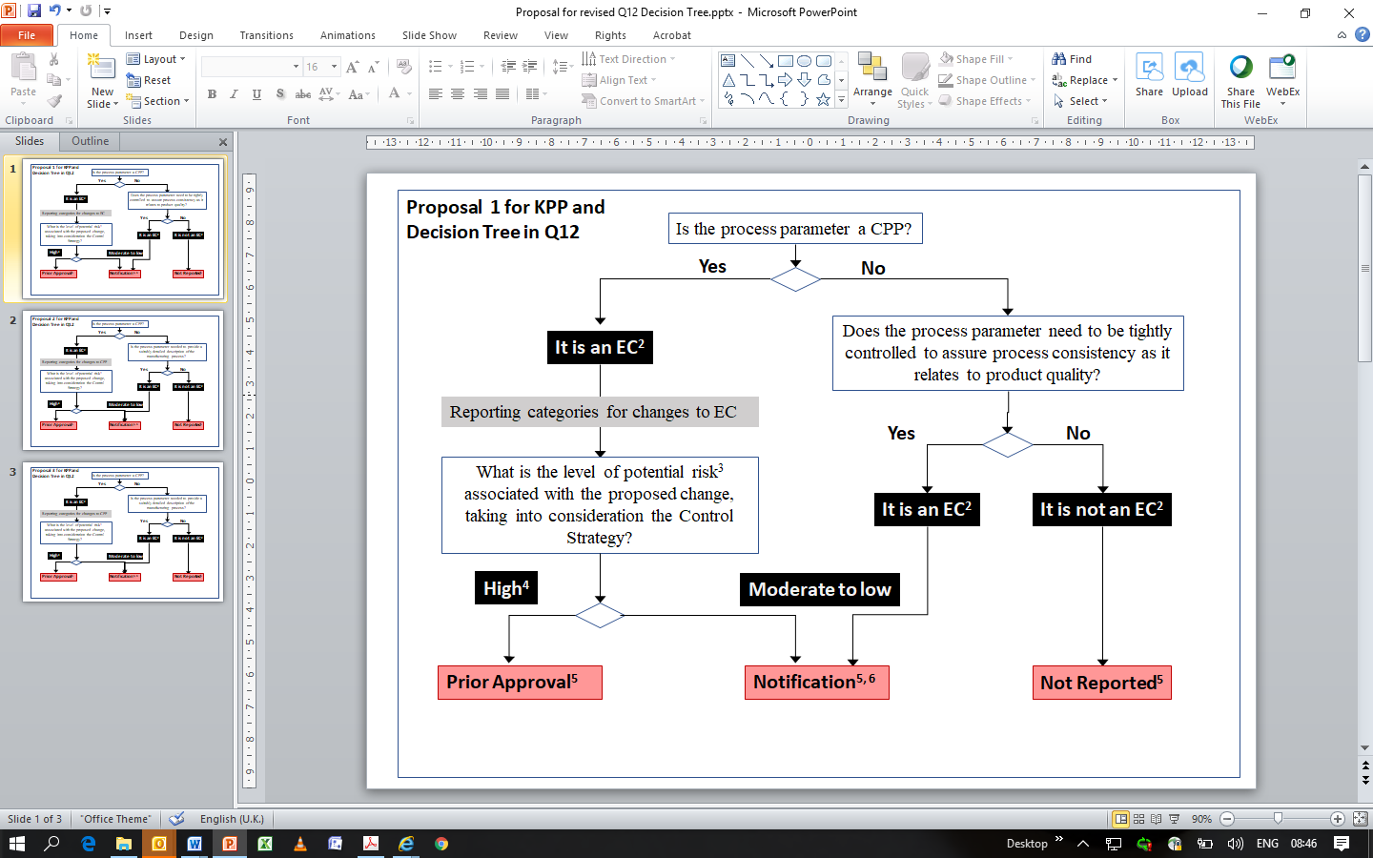
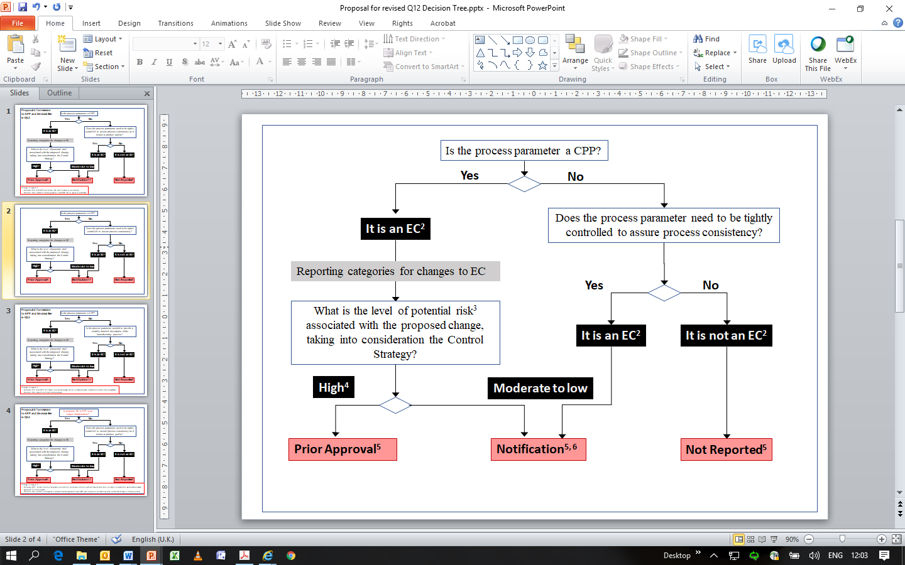
Add new footnote 6 to Figure 1:
“6 Low change reporting category for ECs that are not CPPs: Notification (Annual Report, Type IA, MCN etc).”
Delete footnote 4 to Figure 1: “In some cases, moderate risk changes may require prior approval”
Identification of ECs for Analytical Procedures (Ch 3.2.3.2)
More information is required to explain how established conditions for analytical procedures can be identified/defined, as the current text does not provide enough clarity (lines 290-304).

Proposed change (if any):
3.2.3.2. Identification of ECs for Analytical Procedures

ECs related to analytical procedures should include those elements which assure performance of the procedure. Appropriate justification should be provided to support the identification of ECs for analytical procedures. The extent of ECs could vary based on the method complexity, development and control approaches.

Where the analytical procedure has been validated according to the requirements of ICH Q2(R1), including robustness studies, then ECs may be defined as:
- method principle (e.g. chromatography, IR spectroscopy etc.)
and
- performance, defined by the acceptance criteria specified in the validation protocol (e.g., specificity, accuracy, precision)
The procedure must contain system suitability or other suitable evaluations to confirm that the procedure is meeting the performance requirements.

For some complex analytical procedures it may not be possible to sufficiently describe the performance of the procedure as described above, and some details of operational parameters may also be included as ECs.

Other approaches, for example identifying the critical operational parameters of the procedure, may be used define the ECs for the analytical procedure.

A suitably detailed description of the analytical procedures in Module 3 is expected to provide a clear understanding regardless of the approach used to identify ECs for analytical procedures. Use of this guideline should not lead to providing a less detailed description of analytical procedures in the MAA.

Established Conditions for DMFs (Ch3.3 Line 327-331 )
Please clarify how the confidential information (proprietary information) related to ECs and included in the file can be managed. The DMF system in certain regions (e.g. EU-ASMF and USA-DMF) gives the opportunity to the DMF holder to provide the confidential information directly to Health Authorities (HA). Any questions that the reviewers may have during the DMF assessment are directed to the DMF holder.

Proposed change (if any):
The guideline should explicitly state that all confidential information included in the DMF be reported directly to the HAs in all ICH regions by the DMF holder, and not to the MAH. This is also applicable to annual reportable changes (notifications), which should be submitted by the DMF holder, who is then responsible to inform all MAH with whom a letter of access was granted.

In the case of changes with impact on the product quality, strength, purity, safety and/or regulatory filing, the DMF holder is responsible to inform MAHs of the planned changes, and to provide enough information to support the MAH’s impact evaluation of the change(s) proposed. However, this information provided by the DMF holder normally will not contain confidential information (proprietary information).

Post-Approval Change Management Protocol (PACMP) – Chapter 4
As noted for other Q12 tools, for the PACMP to be a useful regulatory tool across the ICH regions it is often desirable that regulatory agencies approve the same PACMP, and we encourage dialogue between regulatory agencies to facilitate
harmonization across ICH regions on approval of PACMPs.
Certain aspects of this chapter can be improved to reduce the potential for disharmony and confusion during implementation:
- Ch 4.1: Can a PACMP be used without defining the ECs? - Clarify that PACMPs and ECs are independent
- Ch 4.1 (para 2, lines 348-350): Do not state that PACMPs need to be revaluated on a regular basis, but only that their validity should be confirmed before use.
- Ch 4.3: This section should be clear on what is expected as a minimum for a PACMP, rather than state that “some, if not all” of all the bullets are applicable: we propose “would typically include the following e.g.”
- Ch 4.5: This section should also clarify how a PACMP applicable to active substances is handled in referenced submissions (e.g. EU-ASMF, US-DMF). The PACMP contains confidential information, and other supportive information that could also be considered confidential. To guarantee confidentiality, the holder of the referenced submission should be able to submit the PACMP directly to the Heath Authorities (HAs) following the same procedure of the DMF clarifications requested by HAs related to the confidential information of the DMF or the annual report submitted by the DMF holder itself.

Proposed change (if any):
A DMF holder should be able to submit a DMF-related PACMP to the HAs and provide the reference to the MAH, for all types of submissions.
- Ch 4.5: For ‘Broader Protocols’ could the PACMP have to be filed as a stand-alone request to HAs, or could it still be linked to a particular MAA submission?
Product Lifecycle Management (PLCM) – Chapter 5
Certain aspects of this chapter can be improved to reduce the potential for disharmony and confusion during implementation:

Ch 5.1: We acknowledge that the PLCM document is currently proposed as optional and the decision of the company; however, it states in line 450 that submission of the PLCM is ‘encouraged’ but also that the document is ‘expected’ when the MAH proposes explicit ECs. Making the PLCM document part of the regulatory filing could potentially add unnecessary duplication and administrative regulatory burden considering the submission and maintenance of ECs, PLCM and PACMP without significant added benefit. An additional complexity lies in the difficulties inherent to long-term planning in a rapidly changing environment. We recommend the PLCM is a communication tool provided for use by the CMC reviewer alongside the assessment of Module 3 (in Europe). The PLCM document could include additional information if the company felt this would be helpful, for example describing those planned changes to registered detail that the applicant may be considering at the point of file and how the company proposes to manage these changes. Revision of the example in Annex 3 could help to clarify these points.

Proposed change (if any):
(Lines 449-450): Submission of the PLCM document is optional but recommended encouraged; however, the document is expected when the MAH proposes explicit ECs.

Ch 5.1 (lines 452-454): A summary of control strategy is already proposed in ICH Q8 3.3 as part of P.5.6 and in ICH Q11 6.2 as part of S.4.5. or other appropriate CTD section. Therefore requiring this in a PLCM document is redundant.
Proposed change (if any):
Lines 452-454 (Summary of Product Control Strategy) should be deleted.

Ch 5.1(lines 461-465): References to PACMPs in the PLCM should be simplified to reduce the administrative burden. Furthermore a PACMP need not contain references to ECs as they may be used where ECs are not specified, so this requirement should be removed.

Proposed change (if any):
Lines 461-465: PACMPs that are submitted to prospectively manage and implement one or more post-approval changes should are recommended to be listed in the PLCM document.along with the corresponding ECs to be changed. The approval date of the PACMP should be noted in subsequent submissions. If the PACMP is submitted and approved after approval of the original MAA, an updated PLCM document should accompany the PACMP

Ch 5.3 (Lines 475-478): Maintenance of the PLCM document contains a proposal to include an updated PLCM with every post-approval submission for CMC changes – this is an unnecessary, impractical and onerous requirement that should be removed.

Proposed change (if any):
It is recommended that An updated PLCM document should be provided included in post-approval submissions for CMC changes. The updated PLCM document will capture the when there are changes in ECs and other associated elements (reporting category, commitments, PACMP etc.) The MAH should follow regional expectations for maintaining a revision history for the PLCM document

Ch 5.4 (lines 482-483): If included in a dossier, the location of the PLCM document should be harmonized to avoid creation of multiple dossiers across ICH regions.

Proposed change (if any):
Since documents that are similar to the proposed PLCM such as the Japan Application Form/Approved Matters and the Canadian CPID are included in CTD module 1, we suggest the Q12 EWG consider recommending that the PLCM be included in module 1 unless another location is specified in regional regulatory requirements.
Chapter 8 Post-approval changes for marketed products and Section 8.1 Structured approach to analytical procedure changes
The opening sentences of this chapter potentially create confusion by discussing ECs and PACMPs – this section would fit better in the Introduction chapter and the chapter title should be revised to clarify that the chapter discusses Additional approaches to facilitate post-approval changes to marketed products. The scope of section 8.1 needs clarification. It has no relation to the application of ECs and therefore it should be clear that section 8.1 is only applicable to existing marketed/approved products which do not have ECs defined in the dossier.

Proposed change (if any):
8. Additional approaches to facilitate post-approval changes to marketed products
Marketed products can benefit from the application of ECs and PACMPs as described in this guideline. Specifically, ECs and reporting categories can be proposed for a marketed product via a post-approval regulatory submission; a PACMP can also be proposed for planned change(s) to a marketed product. In addition, such products would also benefit from This chapter describes additional approaches to facilitate changes to marketed products: This chapter describes a strategy for a structured approach for frequent CMC changes (e.g., analytical methods) and data requirements for CMC changes (e.g., stability).
8.1. Structured approach to analytical procedure changes
Marketed products have existing analytical procedures that may benefit from advances made in analytical sciences. The intent of this chapter is to incentivize structured implementation of equivalent or better analytical procedures that are fit for purpose, by providing another approach to change analytical procedures in the MA that does not require the use of the EC or PACMP tools described earlier. To use the An approach described below wherein specific criteria are defined for changes to analytical procedures used to test marketed products, the specified criteria must be met and the step-by-step procedure used to manage the change. is described below. If this approach is followed and all criteria are met, then the analytical procedure change can be made with immediate or other post-implementation notification, as appropriate, to the relevant regulatory authorities
Ch 8.1. Structured approach to analytical procedure changes
The scope for changes that could follow the approach described in 8.1 is unnecessarily narrow. Additional changes that could reasonably be in scope of this structured approach could include:
- Model maintenance activities for multivariate methods
- Changes which result in a tighter specification

Proposed change (if any):
Line 549:
- Changes to predictive models used with multivariate methods, except model maintenance activities
Line 570:
Specification changes (e.g., total impurities, potency) cannot be introduced using this mechanism unless tighter/more restrictive acceptance criteria are introduced or they are allowed by existing regional regulations
Addition to Annex
As Q12 also applies to Vaccines, it would be very helpful to include a new Annex which describes common post-approval changes for Vaccines and which show how changes to some process parameters would be managed.
A proposal for an additional Annex 1C is included here:

- Specific comments on text
Line number(s) of the relevant text  (e.g. Lines 20-23) | Stakeholder number  (To be completed by the Agency) | Comment and rationale; proposed changes  (If changes to the wording are suggested, they should be highlighted using 'track changes') | Outcome  (To be completed by the Agency)
Lines 58-146 |  | 1. INTRODUCTION
90-91 |  | Ch 1.2 (lines 90-91) states: "Changes needed to comply with revisions to Pharmacopoeial monographs are not in scope of this guideline".  It is not clear why changes to comply with revisions to pharmacopoeias are excluded from the scope of the guideline, even if in some cases they are not harmonized between the regions. On the contrary, pharmacopoeial changes could be regarded as minor changes to be reported as a notification only, and are often managed internally under the Pharmaceutical Quality System as long as the registration dossier refers to the "current pharmacopoeial monograph".  Proposed change (if any):  Either:  Delete the sentence “Changes needed to comply with revisions to Pharmacopoeial monographs ….guideline”  Or:  Provide additional clarifying text, for example:  “Where the registration dossier refers to the current pharmacopoeial monograph, changes to comply with revisions to the monograph are managed under the Pharmaceutical Quality System, without any regulatory notification.”
Lines 147-193 |  | 2. Categorisation of post-approval CMC changes
166 |  | In Ch 2 (para 3-4, line 166) , it is stated that “an inspection may be associated with such changes”. Further clarification on the inspection time point, whether the inspection takes place before or after the implementation of CMC changes, may be necessary. Examples may be helpful.  As discussed in ch 6.1 (line 488-490), it is important to stress that Q12 does not anticipate any increase in inspections.  Proposed change (if any):  If required by regional regulatory requirements, an inspection may be associated with such changes before (or after) the implementation (e.g, site changes).
Lines 194-332 |  | 3 Established conditions (ECs)
203-204 |  | Ch 3.2.1 (lines 203-204) The definition for ECs text currently states:  “ECs are legally binding information (or approved matters) considered necessary to assure product quality. As a consequence, any change to ECs necessitates a submission to the regulatory authority.”  It is important to state that only ECs are reported, and that for any editorial change to ECs, a submission to the regulatory authority shouldn’t be necessary  Proposed change (if any):  Add:  " As a consequence, only any change to ECs (except editorial changes) necessitates a submission to the regulatory authority.”
277 |  | Comment:  Justification of parameters that are not ECs seems like unnecessary burden on a Marketing Authorization Holder.  Proposed change (if any):  Appropriate justification should be provided in support of the identification of ECs and those aspects that are not ECs.
281 – 282 |  | Ch 3.2.3.1 (Figure 1).  Footnote 1 indicates that the decision tree does not apply for performance-based approaches. Comparable information for performance-based approaches would be helpful to include.  Proposed change (if any):  Please consider that Figure 1 can also be applicable for performance-based approaches and remove footnote 1, or include an explanation or separate decision tree for reporting categories for performance-based approaches so it is clear what is expected in those cases.
312 - 313 |  | Ch 3.2.4 (para 2, lines 312-313)  The ‘Justification may include information such as validation data and batch data’ need to clarify for conditions of information. This can be applied to analytical procedure and manufacturing process. For the analytical procedure, validation data and batch analyses can be collected and used. But for the manufacturing process, many parameters are revised based on manufacturing experience only. We suggest to add ‘or’ in sentence.  Proposed change (if any):  Justification may include information such as validation data and/or batch analyses.
Lines 440-483 |  | 5. PLCM
446 |  | Ch 5.1  Product Lifecycle Management is currently performed by drug substance manufacturers but not communicated to Health Authorities by ASMF/DMF holders. It is unclear if the PLCM document would be applicable to ASMF/DMF holders. In most cases an ASMF/DMF is applicable to more than one MAH, and consequently there may be differences in the control strategy and ECs requirements for different customer applications, and this would need consideration if PLCM concept is applied to ASMF/DMFs.  Proposed change (if any):  Please clarify the scope/applicability of the PLCM concept to ASMF/DMF holders.
Lines 484-513 |  | 6. PQS
512 |  | Ch 6.2 (final bullet, line 512)  Communication mechanisms are typically defined in quality agreements. Contracts deal with commercial matters and requirements for a quality agreement.  Proposed change (if any):  The communication mechanisms regarding MAA changes and GMP issues should be defined in relevant documentation, including quality agreements and/or contracts with CMOs.
Lines 525-674 |  | 8. Marketed Products
562 |  | Ch 8.1.1 (para 1, line 562)  While in general it is understandable that results should be equivalent – particularly in terms of equivalent outcome, method changes may be made to improve performance (e.g. improved precision, accuracy, resolution for control of impurities) that may not lead to “equivalent results” (particularly when comparing results of two methods), but still support equivalent outcomes.  We strongly advocate that the criteria for assessment of method change should be either fully revalidate or perform equivalence testing. It is unnecessary to stipulate both. Where methods are very old comparison of methods would be unnecessarily burdensome. (see also lines 607-608)  Proposed change (if any):  Test results obtained using the original method and revised method should be equivalent to each other or offer improvements (e.g. precision, accuracy). This Equivalency can should be assessed in two ways:  - First, tThe revised method should give an equivalent outcome, i.e., the same quality decision will be made regardless of whether the data was obtained by the original or the revised method.  or  - Second, tThe validation protocol should contain explicit criteria that compare results obtained using the new and revised method. See step 2 below for further details.
Lines 690-698 |  | Appendix 1
698 |  | Appendix 1 (Line 698) Table  Error in CTD numbering.  Proposed change (if any):  Correct 3.3.P.4.3 to 3.2.P.4.3  Correct 3.3.P.4.4 to 3.2.P.4.4
698 |  | Appendix 1 (Line 698) Table Section 3.2.S.2.4 and 3.2.P.3.4 states ECs would be:  “Specifications (e.g., test, elements of analytical procedure and acceptance criteria) for critical steps and intermediates including storage conditions of critical intermediates.”  Specifying the storage conditions here is additional, product-specific detail, inconsistent with the general approach in this table. This detail should be removed.  Proposed change (if any):  ‘Specifications (e.g., test, elements of analytical procedure and acceptance criteria) for critical steps and intermediates including storage conditions of critical intermediates ‘
698 |  | Appendix 1 (Line 698) Table Sections 3.2.S.5 and 3.2.P.6:  Qualification Protocols are successfully used as a mechanism to manage changes to Reference Materials (3.2.S.5 and 3.2.P.6) in a number of regions, particularly for biological products including vaccines. Although the concept has similarities to PACMPs, upon approval of the protocol for certain changes such as the use of a new batch of reference material without changes to the specification, there is no need to report the data in a subsequent regulatory step. Thus the specification of the reference material should be considered as an EC and a Qualification Protocol could be recommended to manage changes to the Reference material that do not result in changes to the specification.  Proposed change (if any):  Reference Material specification qualification (e.g., test, elements of analytical procedure, where appropriate, and acceptance criteria)  Add footnote:  A Qualification Protocol is recommended to manage changes to Reference Material that do not result in changes to its specification.
698 |  | Appendix 1 (Line 698) Table Section 3.2.P.7  This section states that the supplier/manufacturer of a container-closure is an EC. However, this should not be an EC if equivalently sourced materials are appropriately qualified and controlled via the PQS. This requirement should be deleted as an EC.  The container-closure is stated to be provided as “material of construction and specification” but it is considered that there are other ways to provide commitments to container closure than by providing materials statements, for example by providing the Moisture Vapour Transmission Rate (MVTR) which can be considered as a way of describing one aspect of the performance of the container closure system.  Proposed change (if any):  Supplier/manufacturer of container closure  Material of construction and specification (or suitable performance characteristics and acceptance criteria)
698 |  | Appendix 1 (line 698) Table Section 3.2.A.1  ‘Facilities and Equipment’ is listed as an EC per “regional regulation and guidance” but this information should not be considered as ECs because it is GMP-related and regulatory oversight provided through inspection. Additionally, this statement perpetuates regional diversity rather than harmonization.  Proposed change (if any):  Remove statement and mark section as supportive information and a non-EC section.
Lines 699-776 |  | Appendix 2
709 |  | Appendix 2 Point 4 (line 709)  Current statement Point 4 includes elements that are not required under the change management system.  Proposed change (if any):  Requires a science and data based risk assessment and risk categorization of the proposed change including the management of risk in the event the proposed change is not implemented
728 |  | Appendix 2 Point 11 (line 728)  Not all statements in Point 11 (a. to d.) are effectiveness checks – many are post implementation actions. An effectiveness check needs to be focused on whether the change met the desired outcome with no unintended consequences.  Lessons learned activities focus on the business process/project aspect of doing the change, whereas effectiveness checks focus on the quality aspects. The management review, as outlined in ICHQ10, already includes evaluating opportunities for improvement of the PQS.  Proposed change (if any):  10. Captures new product/process knowledge gained during implementation of the change;  10. Verifies, post-implementation, that relevant changes have been effective in achieving the desired outcome with no unintended consequences for product quality  If deviations associated with post-approval changes are detected, ensures that the issue is managed via the firm’s deviation management process and appropriate corrective and/or preventive actions are identified and undertaken via the firm’s corrective and preventive action (CAPA) system  11. Verifies, pPost-implementation, that changes have been effective in achieving the desired outcome with no unintended consequences;  a. Captures new product/process knowledge gained during implementation of the change  If deviations associated with post-approval changes are detected, ensures that the issue is managed via the firm’s deviation management process and appropriate corrective and/or preventive actions are identified and undertaken via the firm’s corrective and preventive action (CAPA) system  b. Where applicable, ensures that regulatory filings are updated and an assessment is made as to whether updates to the PLCM document are needed  c. Requires a post-implementation lessons-learned exercise to build on the product and process knowledge gained with a view to continual improvement, including improvement of the PQS  c. d. Where applicable ensures that the change is included and assessed as part of the Product Quality Review (PQR)
771-773 |  | Appendix 2 Use of Knowledge (para 4, line 771-773)  The statement in Line 773 (“there is no added requirement for a formal knowledge management system”) seems to contradict that line 771 (“use of knowledge … should be described in the PQS”). Q10 does not state “there is no added regulatory requirement for a formal knowledge management system” – this is in ‘Quality Implementation Working Group  on Q8, Q9 and Q10 Questions & Answers (R4)’  Proposed change (if any):  Use of knowledge is the responsibility of the firm and should be described in the PQS (for more detailed information reference is made to ICH Q8, Q9, Q10, Q11, Q/IWG Q&A). As described in ICH Q10 ICH Quality Implementation Working Group on Q8, Q9 and Q10 Questions & Answers (R4), ‘there is no added regulatory requirement for a formal knowledge management system. However it is expected that  knowledge from different processes and systems will be  appropriately utilised.’
ANNEX
66-70 |  | Annex IA (lines 66-70)  With regards to the reporting categories presented in the tables for the small molecule and biologic example, it is not clear how the reporting category relates to proposed changes in ranges (widening versus tightening).  For instance, for homogeneity, NM is proposed for the specification <5% RSD (IPC). It is unclear how the reporting categories are defined when tightening or widening the specifications, and how they will differ (since the risk is different). Can you widen or delete an acceptance range post approval with a notification low (NL) reporting category based on a risk assessment? Shouldn’t the reporting categories correspond to a lower regulatory risk for the performance based approach as more is known about the manufacturing process?  Proposed change (if any):  Clarify how reporting categories change when widening or tightening ranges.
66 |  | Annex IA (lines 66)  Enhanced approach: If the PSD of the API demonstrated no impact on dissolution or absorption, why not consider it as “NR” or “NL”? It demonstrated no impact on quality, so it should fulfil criteria for low or no reporting required.  Proposed change (if any):  Change the reporting category to “NR” or “NL”
106-129 |  | Annex IIA: PACMP Example 1 (lines 106-129)  It would be helpful to:  1. Exemplify alternate approaches to facilitate assessment of change by MAH and regulators for a low risk change and/or one supported by prior knowledge and one that promotes innovation  2. Include an accommodation for continuous manufacture, (e.g. also add commentary around expectations for site change for continuous manufacture.)  The requirements in the bulleted list seem to reflect requirements when a parameter-based approach has been taken even though there is an acknowledgement that these should reflect a lower submission category than provided for in existing guidance i.e. does not seem to take into consideration enhanced or performance-based approaches.  Proposed change (if any):  - In a comparative batch analysis if the risk is low and/or there is prior knowledge, one batch of drug substance manufactured at the alternative manufacturing site should meet approved specification to demonstrate equivalence to batches manufactured at the currently approved site.  - Stability studies will be initiated immediately on one batch of drug substance manufactured at the alternate manufacturing site . Alternate approaches such as modelling could be used to demonstrate comparability of stability profiles of drug substance produced at both sites. Stability data are to be reported to the regulatory authority subsequent to implementation of the new site according to regional requirements.  - specification and analytical methods for starting material or intermediates should be appropriate to control the materials and be equivalent or better  - analytical methods or specification for release and stability testing for drug substance manufactured at the alternative site should be appropriate to control the drug substance and be equivalent or better
113-114 |  | Annex IIA (line 113-114)  Why are DP stability studies needed if lines 124-125 state that there is no change in synthetic route, control strategy, impurity profile or physicochemical properties?  Proposed change (if any):  Remove the requirement for DP stability

