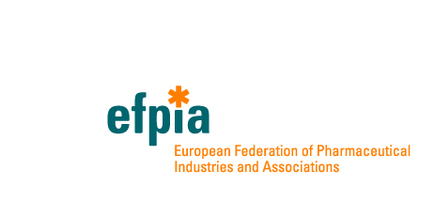
EFPIA response to public consultation on Inception Impact Assessment (November 2020)

Revision of the Blood, Tissues & Cells (BTC) Legislation offers an important opportunity to ensure regulatory standards safeguarding patient safety and public health keep pace with technical and scientific advances, legal certainty and risk-based flexibility to facilitate innovation, and sustainability of supplies across EU for both therapeutic need and producing products derived from BTC.

Keeping pace with science

- The current environment is witnessing a rapid pace of technological and scientific advances rendering current technical aspects of Directive 20016/17 and 2002/98 obsolete or outdated
- Policy options reinforcing adoption of technical standards developed by ECDC and EDQM and leveraging EURO GTP I and II will ensure a dynamic system that can more easily adapt to changes in the current state of science
- New standards governing the safety, quality, availability and use of BTC should be patient-centred and seek synergies between certification, audit, and technical expertise bodies with competent authorities
- Policy options that reinforce the risk-based principles in inspection and control processes will facilitate a proportional and efficient approach to oversight

Legal certainty and flexibility

  - Divergent approaches across Member States (MS) cause unequal levels of safety and quality as well as complexities and uncertainties that disincentivize investment in innovation in Europe
  - A streamlined and rational EU-level framework could provide legal certainty and consistency across MS
  - Policy options that include an EU level mechanism for product classification should be more than advisory, enforceable and leverage, not duplicate or create a parallel pathway to, existing mechanisms for borderline issues (e.g. EMA CAT classification)
- Such a mechanism would allow flexibility to adapt to future innovation, facilitate streamlined procedures, and ensure adherence to a common European standard for quality and safety

Sustainability
- Maintaining self-sufficient supplies of blood, tissues and cells is essential but the current legislation does not provide adequate measures
- Shortages of blood and blood-derived products during COVID-19 have reinforced the risks of supply interruption
- Policy options should reinforce adoption of guidance that ensures sustainability of BTC supply, promoting best practices in managing existing supplies. These could include Patient Blood Management, an approach optimising care of patients who might need a blood transfusion while reducing the amount of blood needed, and plasmapheresis, as an efficient mechanism to collect more plasma. Patient blood management is valuable in the surgical setting and medical care for chronic diseases (including cancer), as around 2/3 of red blood cell transfusions are used in medical care of chronic diseases
- BTCs can be used as starting materials for ATMPs. Policy options should strike a fair balance ensuring innovation is promoted equally across EU without jeopardising patient needs for blood components

Medicinal products and devices based on BTC

- In the interest of patient safety, it is important that medicinal products and devices based on BTC continue to be regulated as medicinal products; BTC regulation must not be exploited to offer medicinal products without seeking EU marketing authorization.

Coordinated EU support is needed for multi-stakeholder expert networks to disseminate best practice across MS between authorities and practitioners to ensure impact of EU-level actions on the ground. European initiatives for training of inspectors and controllers (Eustite, CATIE, VISTART) must also be maintained with more participation from MS.

A holistic approach to revision of BTC Legislation considering the Pharmaceuticals Strategy is welcomed. EFPIA and its members look forward to working with the Commission and other stakeholders to build solutions that support continued innovation in the life sciences to improve patient outcomes and safeguard public health.

